**Unit testing of Sadguru's Amrit Tulya Tea Shop**

1. Open browser type <http://127.0.0.1:8000/>
2. After typing this url you can see the home page .see in below

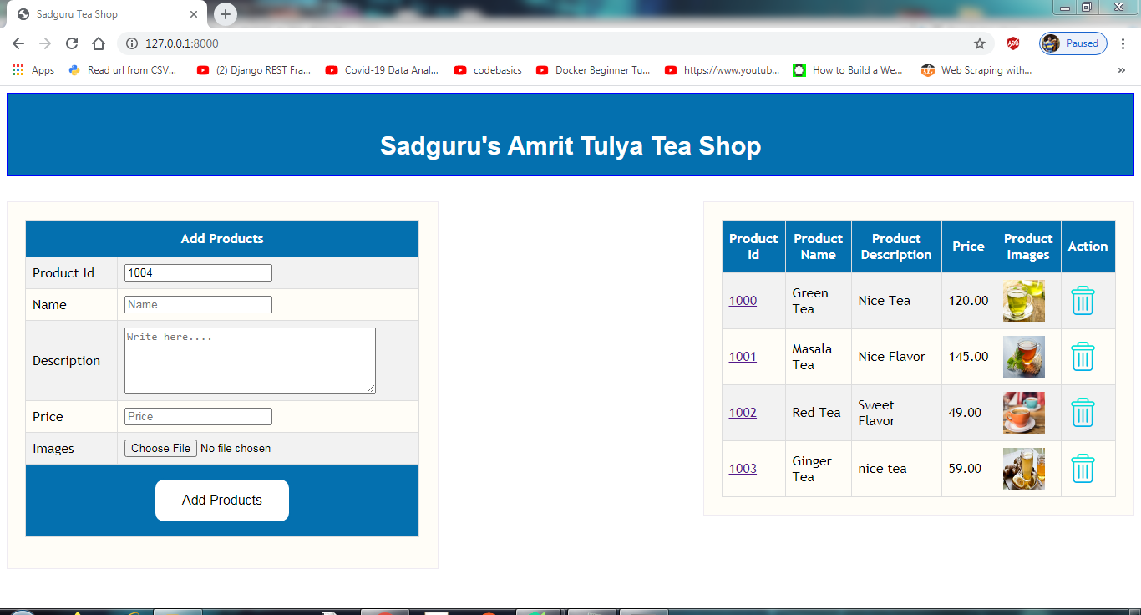

1. After that you can add the product in their respective fields by clicking Add Product button.

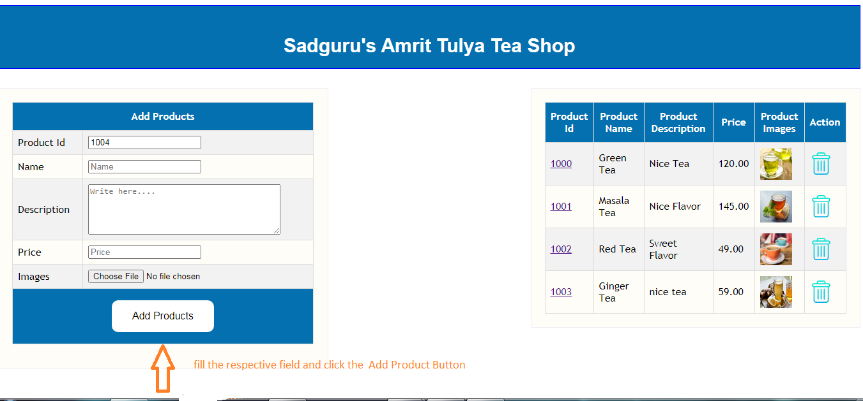

1. After clicking the Add product button, product will added and display all products in right side table.

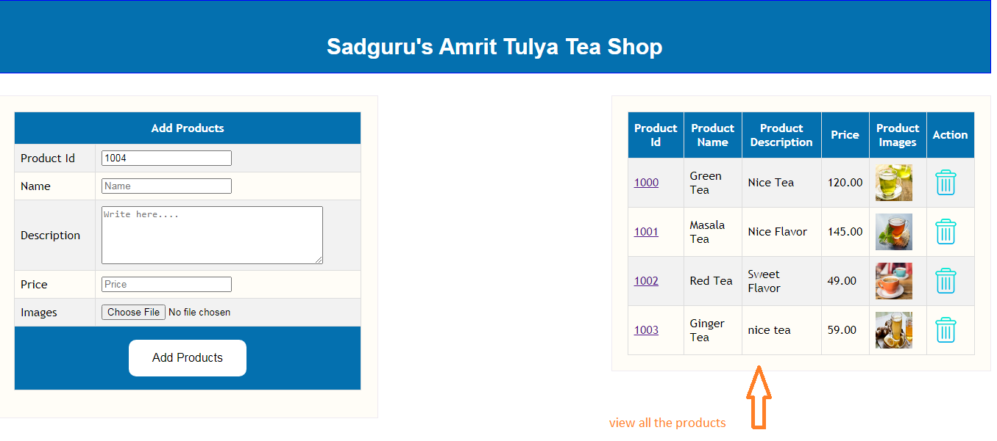

1. Click a id to view the particular product details .

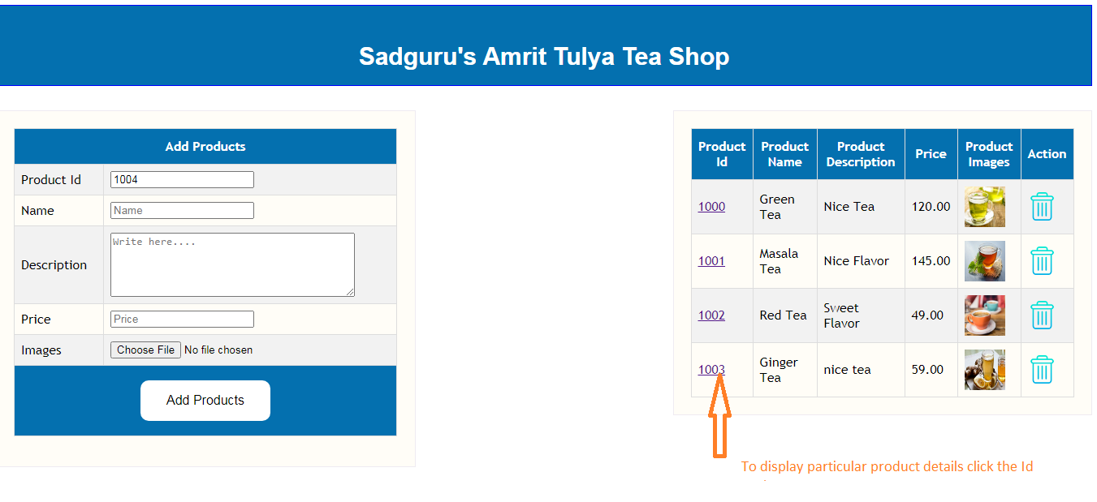

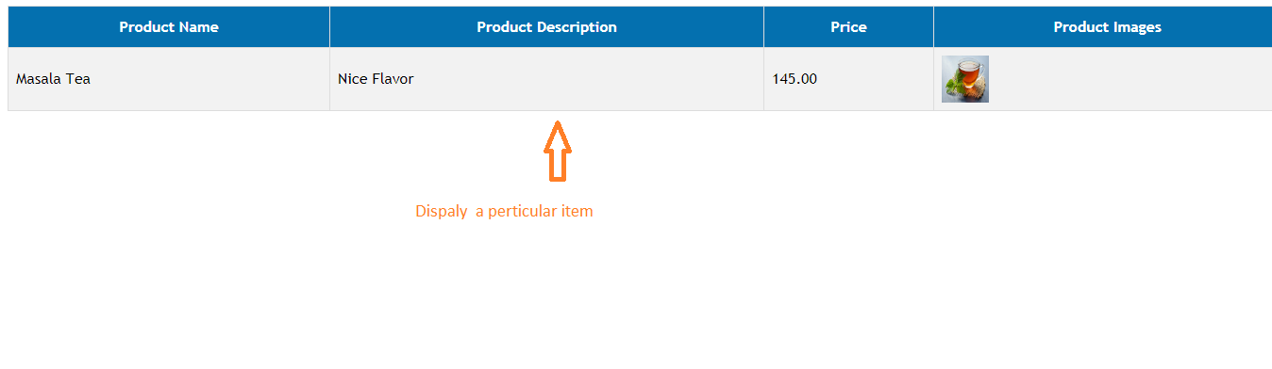

1. To delete particular item click the delete image button.

